Robotics

**Unit 7 User’s Guide**

Building a Color-Sorter

horizontal line

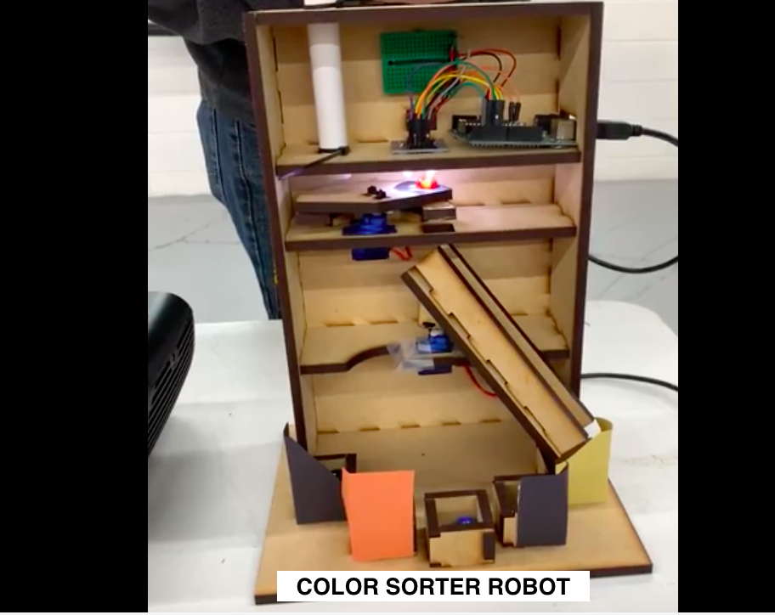

**Ctrl+Alt+Elite**

**CONTENT OF UNIT 7 SLIDES**

# Unit 7: Building a Marble Color Sorter

**Section 1: Servos**

* How to test the servo
  + Move from 0 to 45o and/or 90o

**Section 2: Color Sensor**

* How to test the servo
  + Include the library

**Section 2: Assembly**

* Assemble the pre-cut design puzzle
* Attach the servo and mini-breadboard

**Section 3: Wiring**

* Wire the breadboard, both servos and Arduino
* Following the table provided in the unit

**Section 4: Coding**

* Write and test program for lower servo
* Write and test program for upper servo
* Write and test program for color sorter

# OVERVIEW

# Student will build a robot that sorts marbles by a colors and the place them into different boxes. In this unit, Students will learn to apply all the hardware and software concepts covered thus far to build this robot. Everything required in this unit have been already covered in previous units. Instructor should walk through the process of making a color sorter with the students. A step by step process that will allow the students to successfully build this robot.

# FOCUS STANDARDS

# From our experience implementing this unit, we have selected these focus standards.

# Cut out the designed pieces of the robot

# Mount hardware items

# Wiring to the arduino

# Calibrating the color sensor

# Critical thinking over how servos should react based on the color sensor output

# Programing

# OBJECTIVES

These set objectives are to be checked at the end of this unit. Students should know at least the minimum of the objectives to move forward.

# Color sensor can recognize colors of the marble

* Servos move to the required positions
* Robot successfully sorts out marbles based on different colors

# SAMPLE ACTIVITIES

The activities listed below are to completely by the end of the unit 6. All are build using a breadboard.

* Build circuit with RGB LED and Color Sensor
  + RGB LED should turn to the color of the sensed color by the sensor
* Build circuit with Servo and Color Sensor
  + Servo turns to different position based on the color sensed by the sensor
* Build actual Color-sorting robot using Color Sensor and 2 Servos

# INSTRUCTIONS FOR ASSEMBLY

* Assembly (each instruction will be accompanied by a photograph to help understand each instruction
  + Attach the H-bridge to the foam board such that the leads from the motors can reach the drive pins
  + Attach the Arduino to the foam board (make sure that the proximity of the Arduino to the H-bridge and breadboard are conducive to efficient wiring)
  + Attach the breadboard to the foam board
    - **DO NOT** use the tape provide on the back side of the breadboard
  + Attach the Motors with wheels to the back end of the foam on the bottom
  + Attach the Roller bearing to the front-middle of the foam on the bottom
  + Attach the IR sensors to the front left and right of the foam on the bottom
  + Attach the ultrasonic sensor to the front of the foam (this requires tricky maneuvering of foam and double sided tape)
* Wiring
  + Attach the motor wires to the H-Bridge appropriately
    - red or yellow motor lead to H-bridge motor +
    - black or blue motor lead to H-bridge motor -
  + Wiring the circuit
    - M/F Jumper wire from Arduino pin 5 to H-bridge ENA
    - M/F Jumper wire from Arduino pin 6 to H-bridge IN1
    - M/F Jumper wire from Arduino pin 7 to H-bridge IN2
    - M/F Jumper wire from Arduino pin 8 to H-bridge IN3
    - M/F Jumper wire from Arduino pin 9 to H-bridge IN4
    - M/F Jumper wire from Arduino pin 10 to H-bridge ENB
    - M/M Jumper wire from Arduino Vin to line 1 of breadboard
    - M/M Jumper wire from line 1 of breadboard to H-bridge 5V
    - M/M Jumper wire from Arduino GND to line 2 of breadboard
    - M/M Jumper wire from line 2 of breadboard to H-bridge GND
  + Connecting the IR sensors
    - M/F jumper wire from IR sensor VCC to Arduino 5V via the breadboard
    - M/F jumper wire from IR sensor GND to Arduino GND via the breadboard
    - M/F jumper wire from IR sensor OUT to digital Arduino pin
  + Connecting the ultrasonic sensor
    - M/F jumper wire from Ultrasonic sensor VCC to Arduino 5V via the breadboard
    - M/F jumper wire from Ultrasonic sensor GND to Arduino GND via the breadboard
    - M/F jumper wire from Ultrasonic sensor ECHO to digital Arduino pin
    - M/F jumper wire from Ultrasonic sensor TRIG to digital Arduino pin
  + Connecting the battery
    - 9V battery connector, red wire to 12V on the H-bridge
    - 9V battery connector, black wire to GND pin on the Arduino
* Programming
  + **IMPORTANT**: Never provide power to arduino using both Vin and USB or Barrel Jack
  + Basic H-bridge functions
    - Motor forward (1 pin HIGH, 1 pin LOW)
    - Motor backward (1 pin LOW, 1 pin HIGH)
    - Motor stop (both pins LOW)
  + Functions that simplify these
    - Vehicle forward (both motors forward)
    - Vehicle backward (both motors backwards)
    - Turn right (left motor forward, right motor backwards)
    - Turn left (right motor forward, left motor backwards)
  + Sensor programming
    - Ultrasonic
      * If-else statement
    - IR Sensor
      * Function to see if on track

# WARNINGS AND PRECAUTIONS

* Warnings and precautions:
  + **IMPORTANT**: Never provide power to arduino using both Vin and USB or Barrel Jack
  + **IMPORTANT**: Never touch positive and negative battery terminals together.

**BILL OF MATERIALS**

* **Materials (per student)**
  + 12cm x 12cm foam square
  + Double sided tape
  + 2 Motors w/ wheels
  + H-bridge
  + Arduino
  + Laptop
  + Roller Bearing
  + 9V battery
  + 9V battery cable
  + 2 IR sensors
  + Ultrasonic sensor
  + Mini breadboard
  + ___ M/F jumper wires
  + ___ M/M jumper wires

# 